**FARMER GUIDANCE WEB PORTAL**

**Real -time Research Project (CS456PC)**

Submitted

in partial fulfillment of the requirements for completion of

**Bachelor of Technology IV Semester**

in

**Computer Science and Engineering**

by

**CHIKKUDU CHANDU (22261A0512)**

**and**

**NAIKA NAVANEETH (22261A0535)**

Under the guidance of **Dr. Meera Alphy** (Assistant Professor) and

**Ms. K. Shirisha**

(Assistant Professor)



**Department of Computer Science and Engineering**

**MAHATMA GANDHI INSTITUTE OF TECHNOLOGY (A) GANDIPET, HYDERABAD-500075, TELANGANA (INDIA)**

**2023-2024**

**MAHATMA GANDHI INSTITUTE OF TECHNOLOGY**

**Gandipet, Hyderabad-500075, Telangana (India)**

# CERTIFICATE

This is to certify that the Real Time Research (CS456PC) entitled **“FARMER GUIDANCE WEB PORTAL” is** being submitted by **CHIKKUDU CHANDU bearing roll no. 22261A0512 and NAIKA NAVANEETH** bearing **roll no. 22261A0535** in partial fulfillment for completion of **Bachelor of Technology IV Semester** in **Computer Science and Engineering** to **Mahatma Gandhi Institute of Technology** is a record of bona-fide work carried out under the guidance and supervision. The report is based on the work done entirely by us and not copied from any other source.

**Project Guide** **Head of the Department**

**Dr. Meera Alphy Dr. C.R.K Reddy**

Asst. Professor, Dept. of CSE Professor, Dept. of CSE

**Project Guide**

**Ms. K. Shirisha**

Asst. Professor, Dept. of CSE

# DECLARATION

This is to certify that the work reported in this Real-Time Research Project (CS456PC) titled **“FARMER GUIDANCE WEB PORTAL”** is a record of work done by us in the Department of Computer Science and Engineering, Mahatma Gandhi Institute and Technology, Hyderabad. No part of the work is copied from books/journals/internet and wherever the portion is taken, the same has been duly referred to in the text. The report is based on the work done entirely by us and not copied from any other source.

**CHIKKUDU CHANDU (22261A0512)**

**NAIKA NAVANEETH (22261A0535)**

# ACKNOWLEDGEMENT

The satisfaction that accompanies the successful completion of any task would be incomplete without the mention of people who made it possible because success is the abstract of hard work and perseverance, but steadfast of all is encouraging guidance. So, we acknowledge all those whose guidance and encouragement served as a beacon light and crowned my efforts with success.

We would like to express my sincere thanks to **Prof. G. Chandra Mohan Reddy, Principal, MGIT**, for providing the working facilities in the college.

We wish to express my sincere thanks and gratitude to **Dr. C. R. K. Reddy, Professor and HOD,** Department of CSE, MGIT for all the timely support and valuable suggestions during the period of project.

We are extremely thankful to **Dr. Meera Alphy Assistant Professor & Ms. K Shirisha Assistant Professor,** Department of CSE, MGIT, Real-Time Research Project Coordinators for their encouragement and support throughout the project.

Finally, we would also like to thank all the faculty and staff of the CSE Department who helped us directly or indirectly for completing this project.

**CHIKKUDU CHANDU (22261A0512)**

**NAIKA NAVANEETH (22261A0535)**

**TABLE OF CONTENTS**

CERTIFICATE i

DECLARATION ii

ACKNOWLEDGEMENT iii

LIST OF FIGURES v

LIST OF TABLES vi

ABSTRACT vii

1. INTRODUCTION 1

1.1 Problem Statement 1

1.2 Objectives 1

1.3 Existing System and its Disadvantages 2

1.4 Proposed System and its Advantages 3

1.5 System Requirements 5

2. LITERATURE SURVEY 6

3. DESIGN AND METHODOLOGY 8

3.1 System Architecture 8

3.2 UML Diagram 10

3.3 Sequence Diagram 11

4. RESULTS 12

4.1 Home Page 12

4.2 Field selection 12

4.3 Crop Suggestion 13

4.4 Fertilizer Suggestion 13

4.5 Pesticide Suggestion 14

4.6 Crop Market Rates 14

4.7 Modern Technology Suggestion 15

5. CONCLUSION AND FUTURE SCOPE 16

5.1 Conclusion 16

5.2 Future Scope 16

BIBLIOGRAPHY 17

APPENDIX 18

# LIST OF FIGURES

|  |  |  |
| --- | --- | --- |
| **FIGURE NO.** | **FIGURE NAME** | **PAGE NO.** |
| 3.1    3.2    3.3    4.1 | System Architecture  UML Diagram  Use Case Diagram  Home Page | 8  10  11  12 |
| 4.2  4.3  4.4  4.5  4.6  4.7 | Field selection  Crop suggestion  Fertilizer suggestion  Pesticide suggestion  Crop market rates  Modern technology suggestion | 12  13  13  14  14  15 |
|  |  |  |
|  |  |  |
|  |  |  |

# LIST OF TABLES

|  |  |  |
| --- | --- | --- |
| **TABLE NO.** | **TABLE NAME** | **PAGE NO.** |
| 2.1 | Literature Survey | 5 |

# ABSTRACT

The Farmers' Guide Application is a desktop application for creating graphical user interfaces which helps farmers in agriculture. This comprehensive tool is designed to empower farmers by providing assistance in various aspects of agriculture, including fertilizer selection, pesticide selection, guidance in the crop market, and information about modern machines used in agriculture. The primary goal is to offer an interactive and user-friendly platform where farmers can access personalized recommendations for optimizing their agricultural practices and stay informed about modern technologies. By leveraging this application, farmers can make informed decisions regarding crop selection based on detailed climate and soil analysis. The tool also offers tailored advice on the best fertilizers to use, ensuring soil health and maximizing crop yields. Additionally, it provides effective pesticide selection guidance, emphasizing safe and environmentally friendly pest control methods. The application’s market guidance feature helps farmers understand market trends and demand, enabling them to make strategic decisions to enhance profitability. Furthermore, it introduces farmers to the latest agricultural technologies and machinery, fostering the adoption of innovative practices that can significantly improve efficiency and sustainability in farming operations. Moreover, the Farmers' Guide Application supports continuous learning by offering educational resources and tutorials on various agricultural topics. It integrates data analytics to track farming activities and outcomes, allowing farmers to analyze their performance and make data-driven improvements. With real-time updates and notifications, the application ensures that farmers stay current with the latest agricultural developments and best practices. Ultimately, this tool aims to bridge the gap between traditional farming methods and modern technological advancements, contributing to the overall growth and resilience of the agricultural sector.

# INTRODUCTION

The Farmers' Guide Application is an innovative desktop tool designed to support farmers in optimizing their agricultural practices. This comprehensive application provides personalized assistance in areas such as crop selection, fertilizer and pesticide usage, market guidance, and the adoption of modern agricultural technologies. By offering an interactive and user-friendly platform, the application empowers farmers to make informed decisions, enhance productivity, and stay updated with the latest advancements in agriculture. Through detailed analysis, tailored recommendations, and continuous learning resources, the Farmers' Guide Application aims to bridge the gap between traditional farming methods and modern technological advancements, fostering sustainable and profitable farming operations.

## Problem Statement

The agricultural sector faces several pressing challenges, including inadequate crop selection and limited pest management strategies. Moreover, there are significant hurdles related to user interface designs, impeding efficient navigation and utilization of available resources. Additionally, the integration of modern technologies remains insufficient, hindering advancements in agricultural practices. Furthermore, limited accessibility to essential tools and information exacerbates these issues, posing significant obstacles to the productivity and sustainability of farming operations. Addressing these concerns requires a comprehensive approach that prioritizes innovation, accessibility, and user-friendly solutions within the agricultural domain.

## Objectives

The objectives of this agricultural project encompass several key areas to enhance productivity and sustainability. First, it aims to assist farmers in making informed decisions regarding crop selection, ensuring that the chosen crops are best suited to the local climate and soil conditions. Additionally, the project focuses on the selection of appropriate fertilizers, aiming to optimize soil health and crop yields while minimizing environmental impact. Similarly, pesticide selection is a critical component, with an emphasis on effective pest control measures that are safe for both the environment and the farmers. Beyond these immediate agricultural practices, the project also provides crop market guidance, helping farmers to navigate market trends and demand, thereby maximizing their profitability. Finally, the adoption of modern technologies is a cornerstone of this initiative, promoting innovative tools and practices that can significantly enhance agricultural efficiency and sustainability.

## Existing System and its Disadvantages

The Farmers' Portal on the National Portal of India provides essential resources to support farmers in various aspects of agriculture. It offers detailed guidance on crop selection, helping farmers choose the best crops based on climate, soil, and water availability. For fertilizer selection, the portal provides tailored advice to enhance soil health and crop yields, along with information on government subsidies. Pesticide selection is also covered, offering guidelines for effective and environmentally safe pest control.

**Disadvantages:**

* **Technical knowledge required and Connectivity concerns [2]:**
  + Continued innovation and knowledge transfer will be critical to unlocking the full promise of PA for sustainable agriculture.
  + Limited animations and sound effects reduce the excitement and engagement levels for players.
* **Competition with cash crops [1]:**
  + Cover crops fix atmospheric N2 and build up soil N, which yields subsequent cash crops while reducing N fertilizer requirements.
  + There was a significant variability in SOC response to cover crop use.
* **Dependency on government support [4]:**
  + Some existing systems use inconsistent or poorly designed ball graphics, which can detract from the game's visual coherence.
  + Irregular ball designs can affect the predictability of ball movement, impacting gameplay negatively.
* **Knowledge and skill requirements [3]:**
  + Due to excessive pesticides will cause environmental control them crops and threaten human health; too little pesticides can’t achieve controlling.
  + Impulsive models of pest management consisting of the spraying pesticides

and the pesticide effect of crops.

## Proposed System and its Advantages

The proposed system project stands out from existing portals by offering a comprehensive suite of features aimed at transforming agricultural practices. While many platforms provide basic crop information, our portal goes further by incorporating Crop Selection, Fertilizer Selection, and Pesticide Selection tools, enabling farmers to make precise and informed decisions tailored to their specific needs. Additionally, our Crop Market Guidance feature provides real-time market insights, giving farmers a competitive edge in selling their produce. Furthermore, our platform stands apart with its Modern Machines Information section, offering detailed guidance on state-of-the-art agricultural machinery. By fostering the adoption of modern technologies and providing crucial decision-making tools, our project aims to revolutionize farming practices for increased productivity and sustainability.

**Advantages:**

**1. Comprehensive Decision-Making Tools:** Our platform offers Crop Selection, Fertilizer Selection, and Pesticide Selection tools, empowering farmers to make informed decisions tailored to their specific agricultural needs.

**2. Real-Time Market Insights:** With Crop Market Guidance, farmers have access to up-to-date market trends and prices, enabling them to optimize their crop sales strategies for maximum profitability.

**3. Access to Modern Machinery Information:** Our project provides detailed information on the latest agricultural machinery, helping farmers enhance efficiency and productivity on their farms.

**4. Promotion of Sustainable Practices:** By fostering the adoption of modern technologies, our platform encourages the implementation of sustainable farming practices, leading to improved yields and environmental stewardship.

**5. Enhanced Competitiveness:** Armed with comprehensive decision-making tools and real-time market insights, farmers gain a competitive edge in the agricultural marketplace, ensuring their long-term success.

**6. User-Friendly Interface:** Our platform boasts an intuitive user interface, making it easy for farmers to navigate and utilize its features effectively, even with minimal technical expertise.

**7. Empowerment of Farmers:** Through knowledge and technology dissemination, our project empowers farmers to take control of their agricultural operations, leading to greater autonomy and prosperity in their farming endeavors.

## System Requirements

* + 1. **Software Requirements:**
       - Libraries : Tkinter GUI Library of python
       - Packages : my SQL and pillow package
       - Coding Language : Python IDLE shell new version
    2. **Hardware Requirements:**
       - RAM and Processor : Sufficient RAM to run smoothly and Dual Core Processor
       - OS : Operating system of Windows 10 (64-bit) or later

# LITERATURE SURVEY

Three different approaches to designing a Farmer Guidance are explored in the context of various system architectures and algorithms.

1. **“Advances in Precision Agriculture Technologies for Sustainable Crop**

**Production”, Vikram Singh et.al., [2]** latest advancements in precision agriculture, highlighting their potential to enhance sustainability, increase productivity, and reduce environmental impact. By leveraging cutting-edge technologies such as GPS mapping, remote sensing, and data analytics, precision agriculture enables farmers to make data-driven decisions, optimize resource use, and improve crop yields. Through an exploration of these innovations, we aim to showcase how precision agriculture is transforming farming practices, promoting sustainability, and paving the way for a more resilient and efficient agricultural future. Join us as we investigate the transformative impact of precision agriculture technologies on sustainable crop production.

1. **“Cover Crops Effect on Soil Quality and Soil Health”, M R Rahman et.al., [1]** focuses on growing concerns over agricultural sustainability, the role of cover crops in soil health has garnered significant attention. This journal explores the profound impact of cover crops on soil quality and health, illuminating their potential to mitigate erosion, suppress weeds, improve water retention, and enhance nutrient cycling. Through empirical research and expert insights, we delve into the mechanisms behind cover crops' influence on soil properties and their broader implications for climate resilience and sustainable agriculture. Join us as we uncover the transformative power of covering crops in nurturing healthy soils and building a more sustainable agricultural future.
2. **“Technology Diffusion, Government Policy and Agricultural Sustainable Development”, ZHANG Ju-Yong et.al., [4]** this requires an innovative technology diffusion and supportive government policies. This journal examines the pivotal role that technology diffusion plays in transforming agricultural practices and promoting sustainability. By exploring how government policies can facilitate or hinder the adoption of cutting-edge technologies, we aim to highlight the interplay between policy frameworks and technological advancements. Through case studies, policy analysis, and expert insights, we investigate the strategies that drive successful technology adoption and sustainable development in agriculture. Join us as we delve into the critical nexus of technology, policy, and sustainability, uncovering pathways to a resilient and prosperous agricultural future.
3. **“Optimization Chemical Control in Integrated Pest Management”, Hong Jun Guan et.al., [3]** Integrated Pest Management (IPM) is crucial for balancing agricultural productivity with sustainability. This journal focuses on optimizing chemical control within IPM to enhance pest management while reducing environmental and health impacts. By combining chemical control with biological, cultural, and mechanical methods, farmers can achieve effective pest suppression with minimal pesticide use. We explore innovative approaches and technologies that make chemical use more precise and sustainable. Through case studies and expert insights, we highlight the benefits and challenges of optimizing chemical control in IPM, showcasing its vital role in sustainable agriculture.

Table 2.1 Literature Survey

|  |  |  |  |  |
| --- | --- | --- | --- | --- |
| Title | Authors | Summary | Advantages | Disadvantages |
| Cover Crop’s Effect on Soil Quality and Soil Health [2] | MA Rahman | Cover crops improve soil health, reduce erosion, and enhance crop yields. | * Improved soil health and fertility * Reduced erosion * Increased crop yields | * competition with cash crops * Variable results |
| Advances in Precision Agriculture Technologies for Sustainable Crop Production [1] | Vikram Singh | Precision agriculture technologies optimize resource use and crop management decisions. | * Enhanced resource efficiency * Improved crop monitoring and management * Reduced Environmental footprint | * Technical knowledge required * Connectivity concerns |
| Optimization Chemical Control in Integrated Pest Management [4] | Hong Jun Guan | IPM reduces chemical use and preserves biodiversity | * Preservation of beneficial insects * Long-term pest control effectiveness * Reduced pesticide use | * Knowledge and skill requirements * Initial transition changes |
| Technology Diffusion, Government Policy and Agricultural Sustainable Development [3] | ZHANG Ju-Yong,  YU Yong-Hong | Government subsidies increase access to technology and improve farm productivity. | * Increased access to inputs and technology * Improved productivity * Enhanced resilience | * Dependency on government support |

# 3. DESIGN AND METHODOLOGY

## 3.1 System Architecture

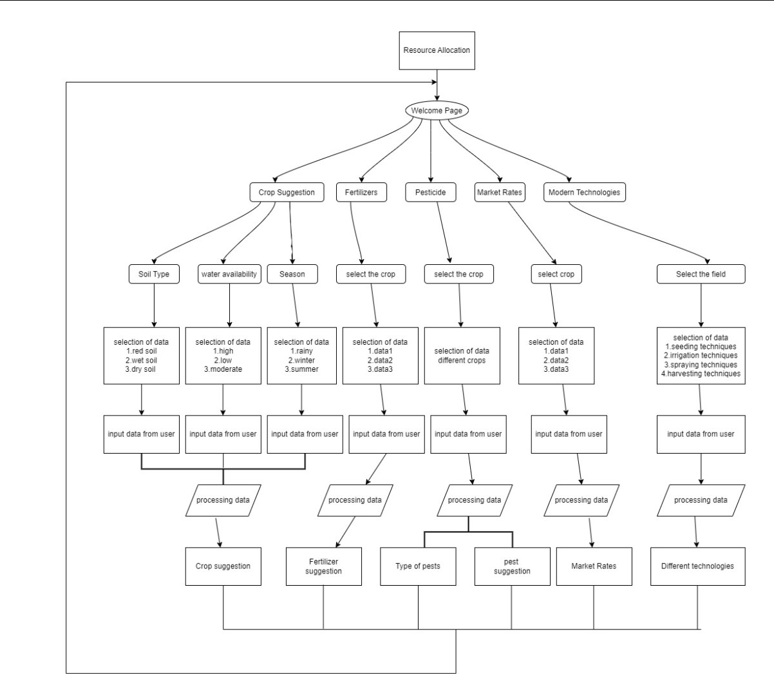

Figure 3.1 System Architecture

The Farmers' Guide Web Portal Application architecture flow of execution begins with the main category of resource allocation, highlighting how farmers distribute various resources for their agricultural practices. From there, the flowchart branches into two essential inputs for crop management: fertilizers and pesticides. Under the “Fertilizers” category, a subcategory called “Crop Suggestion” recommends specific crops based on factors like soil type, climate, and water availability.

Another subcategory, “Modern Technologies,” refers to advanced techniques for fertilizer application, such as precision agriculture or smart irrigation. The flowchart also addresses water availability, emphasizing the importance of proper irrigation for crop health. A decision-making step involves selecting the appropriate crop based on factors like soil tests and other data. Additionally, the flowchart includes data processing, which involves analyzing soil test results, weather data, and other relevant information to optimize farming practices.

1. **Resource Allocation:** At the top of the architect, we have the main category of resource allocation. This refers to how farmers allocate various resources for their agricultural practices.
2. **Fertilizers and Pesticides:** The architect branches into two main categories: fertilizers and pesticides. These are essential inputs for crop management.
3. **Crop Suggestion:** The Crop Suggestion category likely involves recommending specific crops based on factors like soil type, climate, and water availability.
4. **Water Availability:** The flowchart includes a process related to water availability. Proper irrigation is crucial for crop health.
5. **Modern Technologies:** The Modern Technologies category could refer to advanced techniques for fertilizer application, such as precision agriculture or smart irrigation.
6. **Selecting the Crop:** A decision-making step involves selecting the appropriate crop based on various factors. Soil tests and other data play a role here.
7. **Processing Data:** The architect also addresses data processing, which could involve analyzing soil test results, weather data, and other relevant information.

## 3.2 UML Diagram

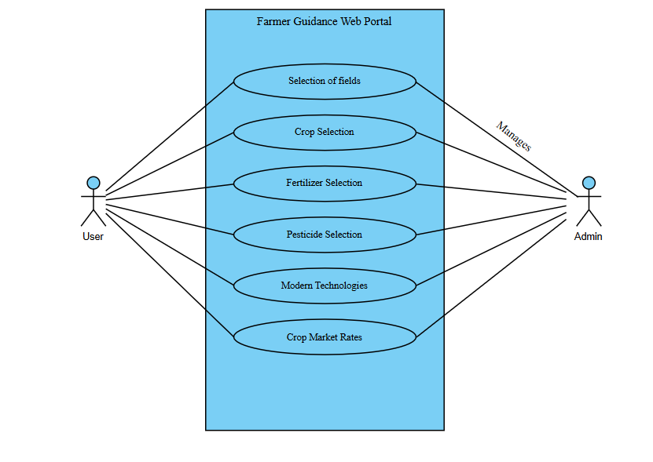

Figure 3.2 Use Case Diagram

Figure 3.2 shows the use case diagram, shows the user will be able to select different fields i.e. crop selection, fertilizer selection, pesticide selection, modern technologies and crop markets, according to the selection of the user the admin will manage the data and shows suggestion according to the user input.

## 3.3 Sequence Diagram

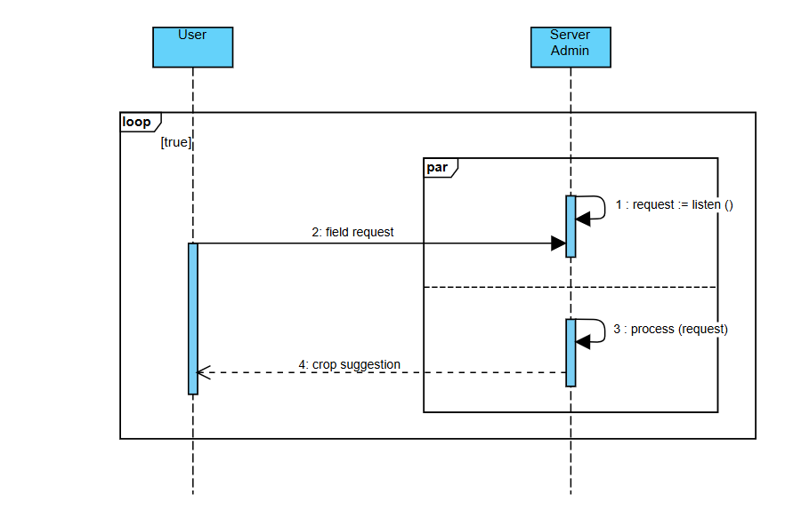

Figure 3.3 Sequence Diagram

Figure 3.3 shows the sequence diagram shows the user need to access the field and make request to the server admin and according to the field the result or crop suggestion given to the user. This process will run in a loop according to the user.

# RESULTS

## 4.1 Home Page

Figure4.1 Home Page

Figure 4.1 shows the opening page of my application which includes the input field of levels, as select the field of different suggestions. When we enter valid input in the given field we need to click on the field.

## 4.2 Field selection

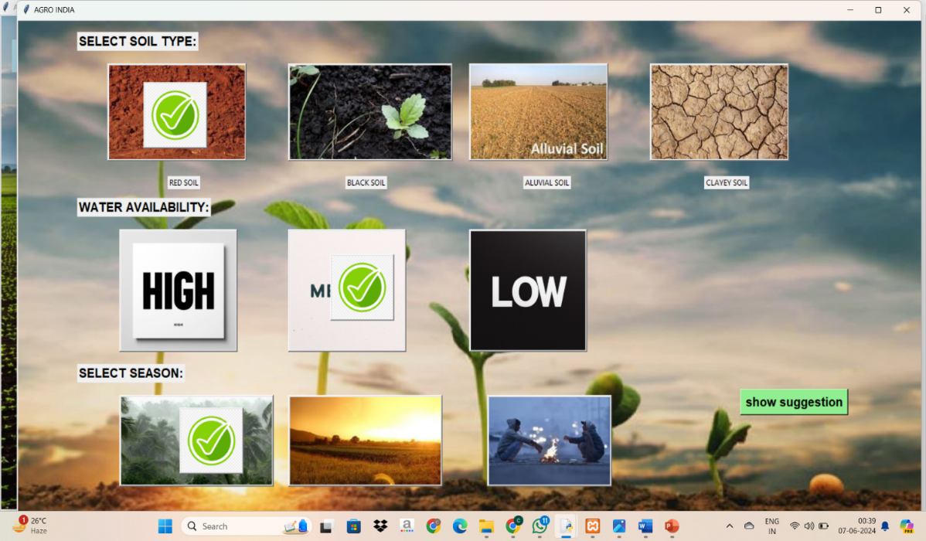

Figure 4.2 Field selection

Figure 4.2 shows the different soil types, water availability and season selection when you select the crop suggestion field, you need to select all the input fields given.

## 4.3 Crop Suggestion

Figure 4.3 Crop Suggestion

Figure 4.3 shows the suggestion of the crop according to the field selections in the previous figures.

## 4.4 Fertilizer Suggestion

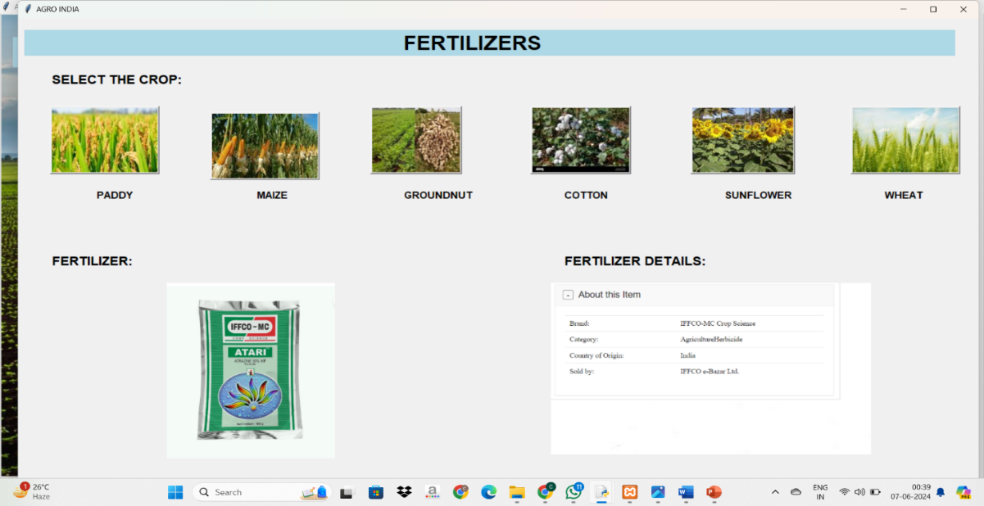

Figure 4.4 Fertilizer selection

Figure 4.4 shows us the different types of crops and the user need to select a crop and according to the field selection the fertilizer suggestion is given to the user.

## 4.5 Pesticide Suggestion

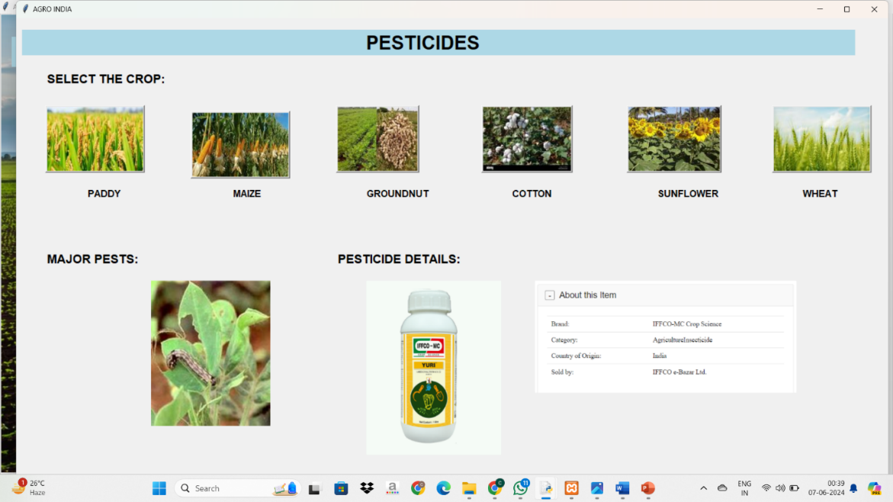

Figure 4.5 Pesticide suggestion

Figure 4.5 shows us the different types of crops and the user needs to select a crop and according to the field selection the pesticide suggestion is given to the user.

## 4.6 Crop Market Rates

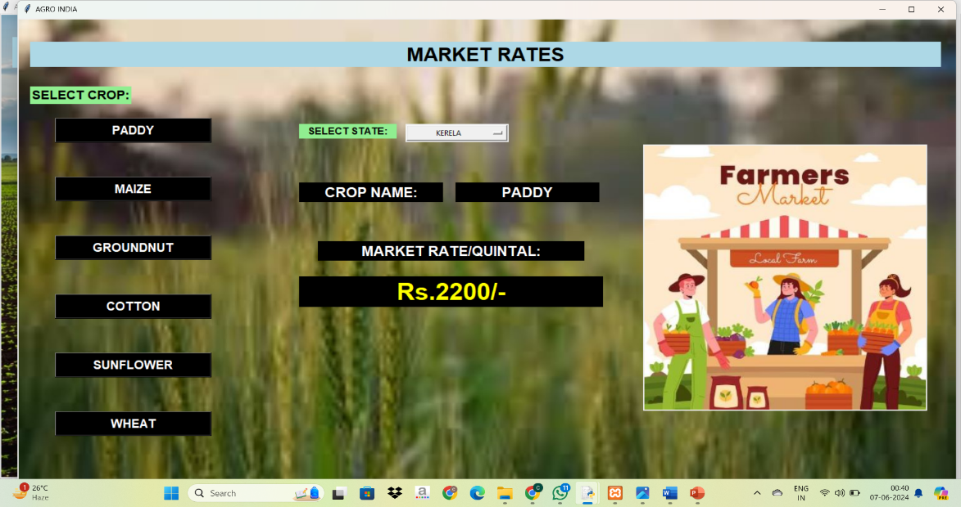

Figure 4.6 Crop Market Rates

Figure 4.6 shows us the different types of crops and the user need to select a crop and according to the field selection the crop market rates are given to the user in different states in India.

## 4.7 Modern Technology Suggestion

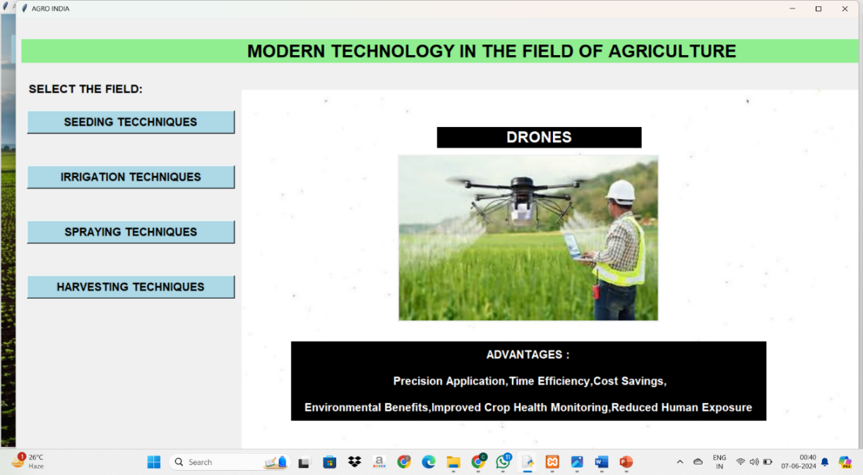

Figure 4.7 Modern Technology suggestion

Figure 4.7 shows us the new technologies present in the market from the start of the crop to the end of the crop, it gives us different fields according to the selection of the user the modern technology is suggested to the user.

# CONCLUSION AND FUTURE SCOPE

## 5.1 Conclusion

Our farmer guidance web portal revolutionizes agricultural support by offering comprehensive tools like Crop Selection, Fertilizer Selection, and Pesticide Selection, empowering farmers with precise, tailored decisions. With real-time Crop Market Guidance and detailed Modern Machines Information, farmers can optimize profitability and efficiency. By promoting the adoption of modern technologies and sustainable practices, our user-friendly platform enhances farming productivity and sustainability. In summary, our web portal equips farmers with essential resources and knowledge, fostering a resilient and prosperous agricultural future.

## 5.2 Future Scope

The future scope of our farmer guidance web portal includes integrating AI and IoT for precise, real-time decision-making, and blockchain for supply chain transparency. Expanding educational resources, developing a mobile app, and providing global market access can further enhance its utility. Strengthening community features and partnering with agricultural institutions, government agencies, and NGOs will foster collaboration and support. Additionally, incorporating sustainability metrics will help farmers improve their environmental impact. These advancements will ensure our platform remains a vital, innovative tool for sustainable and profitable farming.

# BIBLIOGRAPHY

[1]. M A Rahman “Cover Crops Effect on Soil Quality and Soil Health”. American Journal of Plant Sciences, vol 78, no. 2, pp. 124-146, 2021.

[2]. Vikram Singh "Advances in Precision Agriculture Technologies for Sustainable Crop Production”. Journal of Scientific Research and Reports Volume 30, Issue 2, Page 61-71, 2024.

[3]. Hong Jun Guan “Optimization Chemical Control in Integrated Pest Management”, 26th Chinese Control and Decision Conference (CCDC), vol. 10, no. 2, pp. 1022-1026, 2014.

[4]. ZHANG Ju-Yong, YU Yong-Hong “Technology Diffusion, Government Policy and Agricultural Sustainable Development”, International Conference on Management Science & Engineering, vol. 20, no. 4, pp. 2214-2219, 2007.

# APPENDIX

**Main.py**

from tkinter import*

import mysql.connector

from PIL import Image,ImageTk

top=Tk()

top.geometry("1500x1000")

top.title("AGRO INDIA")

i0=Image.open(r"C:\Users\chand\Documents\RTP\images\welcome.jpg")

p0=ImageTk.PhotoImage(i0)

l=Label(top,image=p0)

l.place(x=0,y=0)

global soil

soil=IntVar()

water=IntVar()

season=IntVar()

global s

global z

global x

global y

z=0

x=0

y=0

#home page_____________________________________________________________________________________________________________________________

l=Label(top,text="AGRO INDIA",font="helvetica 30 bold",bg="lightblue",padx=600).place(x=20,y=40)

i=Image.open(r"C:\Users\chand\Documents\RTP\images\happy_farmer.jpg")

p=ImageTk.PhotoImage(i)

l=Label(top,image=p)

l.place(x=100,y=110)

ii=Image.open(r"C:\Users\chand\Documents\RTP\images\logo.jpg")

pp=ImageTk.PhotoImage(ii)

l=Label(top,image=pp)

l.place(x=570,y=110)

ii1=Image.open(r"C:\Users\chand\Documents\RTP\images\drone.jpg")

pp1=ImageTk.PhotoImage(ii1)

l=Label(top,image=pp1)

l.place(x=900,y=110)

l=Label(top,text="Welcome to our cutting-edge agricultural software solution!\n Our mission is to empower farmers with advanced technology to optimize crop yields, reduce resource wastage, and enhance overall productivity.\n Explore our intuitive tools, real-time data analytics, and expert recommendations to revolutionize your farming practices and cultivate a sustainable future.",font="arial 12 bold")

l.place(x=140,y=400)

l=Label(top,text="SELECT THE FIELD:",font="helvetica 15 bold")

l.place(x=680,y=520)

#crop suggestion section______________________________________________________________________________________________________________________

def crop():

top1=Toplevel()

top1.geometry("1500x1000")

top1.title("AGRO INDIA")

i40=Image.open(r"C:\Users\chand\Documents\RTP\images\bg_crop.jpg")

p40=ImageTk.PhotoImage(i40)

l=Label(top1,image=p40).place(x=0,y=0)

l=Label(top1,text="SELECT SOIL TYPE:",font="arial 15 bold").place(x=100,y=20)

soil=IntVar()

def selectred():

global z

if z==0:

z=1

#global s

soil.set(1)

s=soil.get()

i1=Image.open(r"C:\Users\chand\Documents\RTP\images\tickmark.png")

p1=ImageTk.PhotoImage(i1)

b=Button(top1,image=p1).place(x=210,y=100)

top1.mainloop()

def selectblack():

global z

if z==0:

z=2

soil.set(2)

s=soil.get()

#print(soil)

i1=Image.open(r"C:\Users\chand\Documents\RTP\images\tickmark.png")

p1=ImageTk.PhotoImage(i1)

b=Button(top1,image=p1).place(x=550,y=100)

top1.mainloop()

def selectaluvial():

global z

if z==0:

z=3

soil.set(3)

i1=Image.open(r"C:\Users\chand\Documents\RTP\images\tickmark.png")

p1=ImageTk.PhotoImage(i1)

b=Button(top1,image=p1).place(x=850,y=100)

top1.mainloop()

def selectclayey():

global z

if z==0:

z=4

soil.set(4)

i1=Image.open(r"C:\Users\chand\Documents\RTP\images\tickmark.png")

p1=ImageTk.PhotoImage(i1)

b=Button(top1,image=p1).place(x=1150,y=100)

top1.mainloop()

#soil selection

i1=Image.open(r"C:\Users\chand\Documents\RTP\images\redsoil.jpg")

p1=ImageTk.PhotoImage(i1)

b=Button(top1,image=p1,command=selectred).place(x=150,y=70)

l=Label(top1,text="RED SOIL").place(x=250,y=250)

i2=Image.open(r"C:\Users\chand\Documents\RTP\images\blacksoil.jpg")

p2=ImageTk.PhotoImage(i2)

b=Button(top1,image=p2,command=selectblack).place(x=450,y=70)

l=Label(top1,text="BLACK SOIL").place(x=545,y=250)

i3=Image.open(r"C:\Users\chand\Documents\RTP\images\aluvialsoil.jpg")

p3=ImageTk.PhotoImage(i3)

b=Button(top1,image=p3,command=selectaluvial).place(x=750,y=70)

l=Label(top1,text="ALUVIAL SOIL").place(x=840,y=250)

i4=Image.open(r"C:\Users\chand\Documents\RTP\images\claveysoil.jpg")

p4=ImageTk.PhotoImage(i4)

b=Button(top1,image=p4,command=selectclayey).place(x=1050,y=70)

l=Label(top1,text="CLAYEY SOIL").place(x=1140,y=250)

#water availability selection

l=Label(top1,text="WATER AVAILABILITY:",font="arial 15 bold",fg="black").place(x=100,y=285)

def selecthigh():

global x

if x==0:

x=1

water.set(1)

i1=Image.open(r"C:\Users\chand\Documents\RTP\images\tickmark.png")

p1=ImageTk.PhotoImage(i1)

b=Button(top1,image=p1).place(x=230,y=375)

top1.mainloop()

def selectmedium():

global x

if x==0:

x=2

water.set(2)

i1=Image.open(r"C:\Users\chand\Documents\RTP\images\tickmark.png")

p1=ImageTk.PhotoImage(i1)

b=Button(top1,image=p1).place(x=520,y=375)

top1.mainloop()

def selectlow():

global x

if x==0:

x=3

water.set(3)

i1=Image.open(r"C:\Users\chand\Documents\RTP\images\tickmark.png")

p1=ImageTk.PhotoImage(i1)

b=Button(top1,image=p1).place(x=820,y=375)

top1.mainloop()

i5=Image.open(r"C:\Users\chand\Documents\RTP\images\high.png")

p5=ImageTk.PhotoImage(i5)

b=Button(top1,image=p5,command=selecthigh).place(x=170,y=335)

i6=Image.open(r"C:\Users\chand\Documents\RTP\images\medium.png")

p6=ImageTk.PhotoImage(i6)

b=Button(top1,image=p6,command=selectmedium).place(x=450,y=335)

i7=Image.open(r"C:\Users\chand\Documents\RTP\images\low.png")

p7=ImageTk.PhotoImage(i7)

b=Button(top1,image=p7,command=selectlow).place(x=750,y=335)

#SEASON SELECTION

l=Label(top1,text="SELECT SEASON:",font="arial 15 bold",fg="black").place(x=100,y=550)

def selectrainy():

global y

if y==0:

y=1

season.set(1)

i1=Image.open(r"C:\Users\chand\Documents\RTP\images\tickmark.png")

p1=ImageTk.PhotoImage(i1)

b=Button(top1,image=p1).place(x=270,y=620)

top1.mainloop()

def selectsummer():

global y

if y==0:

y=1

season.set(2)

i1=Image.open(r"C:\Users\chand\Documents\RTP\images\tickmark.png")

p1=ImageTk.PhotoImage(i1)

b=Button(top1,image=p1).place(x=550,y=620)

top1.mainloop()

def selectwinter():

global y

if y==0:

y=1

season.set(3)

i1=Image.open(r"C:\Users\chand\Documents\RTP\images\tickmark.png")

p1=ImageTk.PhotoImage(i1)

b=Button(top1,image=p1).place(x=850,y=620)

top1.mainloop()

i8=Image.open(r"C:\Users\chand\Documents\RTP\images\rainy.jpg")

p8=ImageTk.PhotoImage(i8)

b=Button(top1,image=p8,command=selectrainy).place(x=170,y=600)

i9=Image.open(r"C:\Users\chand\Documents\RTP\images\summer.jpg")

p9=ImageTk.PhotoImage(i9)

b=Button(top1,image=p9,command=selectsummer).place(x=450,y=600)

i10=Image.open(r"C:\Users\chand\Documents\RTP\images\winter.jpg")

p10=ImageTk.PhotoImage(i10)

b=Button(top1,image=p10,command=selectwinter).place(x=780,y=600)

#crop suggestion

def seedsuggestion():

global s

s=soil.get()

w=water.get()

sea=season.get()

top2=Toplevel()

top2.geometry("1500x1000")

top2.title("AGRO INDIA")

i41=Image.open(r"C:\Users\chand\Documents\RTP\images\welcome.jpg")

p41=ImageTk.PhotoImage(i41)

l=Label(top2,image=p41).place(x=0,y=0)

l=Label(top2,text="RECOMENDATIONS FOR CROPS AND SEEDS: ",font="helvetica 25 bold",bg="lightblue",padx=50).place(x=60,y=50)

l=Label(top2,text=" SUITABLE CROP :",font="helvetica 15 bold",bg="lightgreen").place(x=100,y=200)

l=Label(top2,text=" SEED RECOMENDATION:",font="helvetica 15 bold",bg="lightgreen").place(x=900,y=200)

#paddy

if s==4 :

if w==1 and sea==2:

i11=Image.open(r"C:\Users\chand\Documents\RTP\images\paddy.jpg")

p11=ImageTk.PhotoImage(i11)

l=Label(top2,image=p11)

l.place(x=230,y=300)

l=Label(top2,text="paddy",font="helvetica 15 bold").place(x=380,y=590)

i12=Image.open(r"C:\Users\chand\Documents\RTP\images\paddy seeds.png")

p12=ImageTk.PhotoImage(i12)

l1=Label(top2,image=p12)

l1.place(x=1030,y=300)

top2.mainloop()

elif w==2 and sea==1:

i13=Image.open(r"C:\Users\chand\Documents\RTP\images\paddy.jpg")

p13=ImageTk.PhotoImage(i13)

l1=Label(top2,image=p13)

l1.place(x=230,y=300)

l=Label(top2,text="PADDY",font="helvetica 15 bold").place(x=380,y=590)

i14=Image.open(r"C:\Users\chand\Documents\RTP\images\paddy seeds.png")

p14=ImageTk.PhotoImage(i14)

l1=Label(top2,image=p14)

l1.place(x=1030,y=300)

top2.mainloop()

#maize

if s==1 and w==2 and sea==1:

i15=Image.open(r"C:\Users\chand\Documents\RTP\images\maize.jpeg")

p15=ImageTk.PhotoImage(i15)

l1=Label(top2,image=p15)

l1.place(x=230,y=300)

l=Label(top2,text="MAIZE",font="helvetica 15 bold").place(x=380,y=590)

i16=Image.open(r"C:\Users\chand\Documents\RTP\images\maize seeds.jpg")

p16=ImageTk.PhotoImage(i16)

l1=Label(top2,image=p16)

l1.place(x=1030,y=300)

top2.mainloop()

#cotton

if s==2 and w==2 and sea==1:

i17=Image.open(r"C:\Users\chand\Documents\RTP\images\Cotton.JPG")

p17=ImageTk.PhotoImage(i17)

l1=Label(top2,image=p17)

l1.place(x=230,y=300)

l=Label(top2,text="COTTON",font="helvetica 15 bold").place(x=380,y=590)

i18=Image.open(r"C:\Users\chand\Documents\RTP\images\cotton seeds.jpeg")

p18=ImageTk.PhotoImage(i18)

l1=Label(top2,image=p18)

l1.place(x=1030,y=300)

top2.mainloop()

#pulses

if s==1 and w==3 and sea==1:

i19=Image.open(r"C:\Users\chand\Documents\RTP\images\groundnut.jpeg")

p19=ImageTk.PhotoImage(i19)

l1=Label(top2,image=p19)

l1.place(x=230,y=300)

l=Label(top2,text="GROUNDNUT",font="helvetica 15 bold").place(x=380,y=590)

i20=Image.open(r"C:\Users\chand\Documents\RTP\images\groundnut seeds.jpeg")

p20=ImageTk.PhotoImage(i20)

l1=Label(top2,image=p20)

l1.place(x=1030,y=300)

top2.mainloop()

#sunflower

if s==2 and w==3 and sea==2:

i21=Image.open(r"C:\Users\chand\Documents\RTP\images\sunflower.jpg")

p21=ImageTk.PhotoImage(i21)

l1=Label(top2,image=p21)

l1.place(x=230,y=300)

l=Label(top2,text="SUNFLOWER",font="helvetica 15 bold").place(x=380,y=590)

i22=Image.open(r"C:\Users\chand\Documents\RTP\images\sunflower seeds.jpeg")

p22=ImageTk.PhotoImage(i22)

l1=Label(top2,image=p22)

l1.place(x=1030,y=300)

top2.mainloop()

#wheat

if s==3:

if w==1 and sea==2:

i23=Image.open(r"C:\Users\chand\Documents\RTP\images\wheat.jpeg")

p23=ImageTk.PhotoImage(i23)

l1=Label(top2,image=p23)

l1.place(x=230,y=300)

l=Label(top2,text="WHEAT",font="helvetica 15 bold").place(x=380,y=590)

i24=Image.open(r"C:\Users\chand\Documents\RTP\images\wheat seeds.jpg")

p24=ImageTk.PhotoImage(i24)

l1=Label(top2,image=p24)

l1.place(x=1030,y=300)

top2.mainloop()

elif w==2 and sea==1:

i25=Image.open(r"C:\Users\chand\Documents\RTP\images\wheat.jpeg")

p25=ImageTk.PhotoImage(i25)

l1=Label(top2,image=p25)

l1.place(x=230,y=300)

l=Label(top2,text="WHEAT",font="helvetica 15 bold").place(x=380,y=590)

i26=Image.open(r"C:\Users\chand\Documents\RTP\images\wheat seeds.jpg")

p26=ImageTk.PhotoImage(i26)

l1=Label(top2,image=p26)

l1.place(x=1030,y=300)

top2.mainloop()

b=Button(top1,text="show suggestion",font="arial 15 bold",bg="lightgreen",command=seedsuggestion).place(x=1200,y=590)

top1.mainloop()

#fertilizers suggestion section__________________________________________________________________________________________________

def fertilizer():

top4=Toplevel()

top4.geometry("1500x1000")

top4.title("AGRO INDIA")

l=Label(top4,text=" FERTILIZERS ",font="arial 25 bold",fg="black",bg="lightblue",padx=500).place(x=10,y=20)

l=Label(top4,text="SELECT THE CROP:",font="arial 16 bold",fg="black").place(x=50,y=90)

l=Label(top4,text="FERTILIZER:",font="arial 16 bold",fg="black").place(x=50,y=400)

l=Label(top4,text="FERTILIZER DETAILS:",font="arial 16 bold",fg="black").place(x=850,y=400)

def paddyfertilizer():

i34=Image.open(r"C:\Users\chand\Documents\RTP\images\whitebg.jpg")

p34=ImageTk.PhotoImage(i34)

l=Label(top4,image=p34)

l.place(x=230,y=450)

i35=Image.open(r"C:\Users\chand\Documents\RTP\images\whitebg.jpg")

p35=ImageTk.PhotoImage(i35)

l=Label(top4,image=p35)

l.place(x=830,y=450)

i34=Image.open(r"C:\Users\chand\Documents\RTP\images\paddy_fertilizer_det.jpg")

p34=ImageTk.PhotoImage(i34)

l=Label(top4,image=p34)

l.place(x=830,y=450)

i33=Image.open(r"C:\Users\chand\Documents\RTP\images\paddy_fertilizer.jpg")

p33=ImageTk.PhotoImage(i33)

l=Label(top4,image=p33)

l.place(x=230,y=450)

top4.mainloop()

def maizefertilizer():

i34=Image.open(r"C:\Users\chand\Documents\RTP\images\whitebg.jpg")

p34=ImageTk.PhotoImage(i34)

l=Label(top4,image=p34)

l.place(x=230,y=450)

i35=Image.open(r"C:\Users\chand\Documents\RTP\images\whitebg.jpg")

p35=ImageTk.PhotoImage(i35)

l=Label(top4,image=p35)

l.place(x=830,y=450)

i34=Image.open(r"C:\Users\chand\Documents\RTP\images\maize_fertilizer_det.png")

p34=ImageTk.PhotoImage(i34)

l=Label(top4,image=p34)

l.place(x=830,y=450)

i33=Image.open(r"C:\Users\chand\Documents\RTP\images\maize_fertilizer.png")

p33=ImageTk.PhotoImage(i33)

l=Label(top4,image=p33)

l.place(x=230,y=450)

top4.mainloop()

def groundnutfertilizer():

i34=Image.open(r"C:\Users\chand\Documents\RTP\images\whitebg.jpg")

p34=ImageTk.PhotoImage(i34)

l=Label(top4,image=p34)

l.place(x=230,y=450)

i35=Image.open(r"C:\Users\chand\Documents\RTP\images\whitebg.jpg")

p35=ImageTk.PhotoImage(i35)

l=Label(top4,image=p35)

l.place(x=830,y=450)

i34=Image.open(r"C:\Users\chand\Documents\RTP\images\groundnut_fertilizer_det.png")

p34=ImageTk.PhotoImage(i34)

l=Label(top4,image=p34)

l.place(x=830,y=450)

i33=Image.open(r"C:\Users\chand\Documents\RTP\images\groundnut_fertilizer.png")

p33=ImageTk.PhotoImage(i33)

l=Label(top4,image=p33)

l.place(x=230,y=450)

top4.mainloop()

def cottonfertilizer():

i34=Image.open(r"C:\Users\chand\Documents\RTP\images\whitebg.jpg")

p34=ImageTk.PhotoImage(i34)

l=Label(top4,image=p34)

l.place(x=230,y=450)

i35=Image.open(r"C:\Users\chand\Documents\RTP\images\whitebg.jpg")

p35=ImageTk.PhotoImage(i35)

l=Label(top4,image=p35)

l.place(x=830,y=450)

i34=Image.open(r"C:\Users\chand\Documents\RTP\images\cotton_fetilizer_det.png")

p34=ImageTk.PhotoImage(i34)

l=Label(top4,image=p34)

l.place(x=830,y=450)

i33=Image.open(r"C:\Users\chand\Documents\RTP\images\cotton_fertilizer.png")

p33=ImageTk.PhotoImage(i33)

l=Label(top4,image=p33)

l.place(x=230,y=450)

top4.mainloop()

def sunflowerfertilizer():

i34=Image.open(r"C:\Users\chand\Documents\RTP\images\whitebg.jpg")

p34=ImageTk.PhotoImage(i34)

l=Label(top4,image=p34)

l.place(x=230,y=450)

i35=Image.open(r"C:\Users\chand\Documents\RTP\images\whitebg.jpg")

p35=ImageTk.PhotoImage(i35)

l=Label(top4,image=p35)

l.place(x=830,y=450)

i34=Image.open(r"C:\Users\chand\Documents\RTP\images\sunflower_fertilizer_det.png")

p34=ImageTk.PhotoImage(i34)

l=Label(top4,image=p34)

l.place(x=830,y=450)

i33=Image.open(r"C:\Users\chand\Documents\RTP\images\sunflower_fertilizer.png")

p33=ImageTk.PhotoImage(i33)

l=Label(top4,image=p33)

l.place(x=230,y=450)

top4.mainloop()

def wheatfertilizer():

i34=Image.open(r"C:\Users\chand\Documents\RTP\images\whitebg.jpg")

p34=ImageTk.PhotoImage(i34)

l=Label(top4,image=p34)

l.place(x=230,y=450)

i35=Image.open(r"C:\Users\chand\Documents\RTP\images\whitebg.jpg")

p35=ImageTk.PhotoImage(i35)

l=Label(top4,image=p35)

l.place(x=830,y=450)

i34=Image.open(r"C:\Users\chand\Documents\RTP\images\wheat_fertilizer_det.png")

p34=ImageTk.PhotoImage(i34)

l=Label(top4,image=p34)

l.place(x=830,y=450)

i33=Image.open(r"C:\Users\chand\Documents\RTP\images\wheat_fertilizer.png")

p33=ImageTk.PhotoImage(i33)

l=Label(top4,image=p33)

l.place(x=230,y=450)

top4.mainloop()

i27=Image.open(r"C:\Users\chand\Documents\RTP\images\fertilizers section\paddy.jpg")

p27=ImageTk.PhotoImage(i27)

b=Button(top4,image=p27,command=paddyfertilizer)

b.place(x=50,y=150)

i28=Image.open(r"C:\Users\chand\Documents\RTP\images\fertilizers section\maize.jpg")

p28=ImageTk.PhotoImage(i28)

b=Button(top4,image=p28,command=maizefertilizer)

b.place(x=300,y=160)

i29=Image.open(r"C:\Users\chand\Documents\RTP\images\fertilizers section\groundnut.jpg")

p29=ImageTk.PhotoImage(i29)

b=Button(top4,image=p29,command=groundnutfertilizer)

b.place(x=550,y=150)

i30=Image.open(r"C:\Users\chand\Documents\RTP\images\fertilizers section\cotton.jpg")

p30=ImageTk.PhotoImage(i30)

b=Button(top4,image=p30,command=cottonfertilizer)

b.place(x=800,y=150)

i31=Image.open(r"C:\Users\chand\Documents\RTP\images\fertilizers section\sunflower.jpg")

p31=ImageTk.PhotoImage(i31)

b=Button(top4,image=p31,command=sunflowerfertilizer)

b.place(x=1050,y=150)

i32=Image.open(r"C:\Users\chand\Documents\RTP\images\fertilizers section\wheat.jpg")

p32=ImageTk.PhotoImage(i32)

b=Button(top4,image=p32,command=wheatfertilizer)

b.place(x=1300,y=150)

l=Label(top4,text="PADDY",font="arial 12 bold").place(x=120,y=290)

l=Label(top4,text="MAIZE",font="arial 12 bold").place(x=370,y=290)

l=Label(top4,text="GROUNDNUT",font="arial 12 bold").place(x=600,y=290)

l=Label(top4,text="COTTON",font="arial 12 bold").place(x=850,y=290)

l=Label(top4,text="SUNFLOWER",font="arial 12 bold").place(x=1100,y=290)

l=Label(top4,text="WHEAT",font="arial 12 bold").place(x=1350,y=290)

top4.mainloop()

#pesticide

def pesticide():

top4=Toplevel()

top4.geometry("1500x1000")

top4.title("AGRO INDIA")

l=Label(top4,text=" PESTICIDES ",font="arial 25 bold",fg="black",bg="lightblue",padx=500).place(x=10,y=20)

l=Label(top4,text="SELECT THE CROP:",font="arial 16 bold",fg="black").place(x=50,y=90)

l=Label(top4,text="MAJOR PESTS:",font="arial 16 bold",fg="black").place(x=50,y=400)

l=Label(top4,text="PESTICIDE DETAILS:",font="arial 16 bold",fg="black").place(x=550,y=400)

def paddypesticide():

i34=Image.open(r"C:\Users\chand\Documents\RTP\images\whitebgpest.png")

p34=ImageTk.PhotoImage(i34)

l=Label(top4,image=p34)

l.place(x=10,y=450)

i36=Image.open(r"C:\Users\chand\Documents\RTP\images\paddy_pesticide.png")

p36=ImageTk.PhotoImage(i36)

l=Label(top4,image=p36)

l.place(x=600,y=450)

i37=Image.open(r"C:\Users\chand\Documents\RTP\images\paddy_pesticide_det.png")

p37=ImageTk.PhotoImage(i37)

l=Label(top4,image=p37)

l.place(x=880,y=480)

i38=Image.open(r"C:\Users\chand\Documents\RTP\images\Paddy_insect.png")

p38=ImageTk.PhotoImage(i38)

l=Label(top4,image=p38)

l.place(x=130,y=450)

top4.mainloop()

def maizepesticide():

i34=Image.open(r"C:\Users\chand\Documents\RTP\images\whitebgpest.png")

p34=ImageTk.PhotoImage(i34)

l=Label(top4,image=p34)

l.place(x=10,y=450)

i37=Image.open(r"C:\Users\chand\Documents\RTP\images\maize_pesticide_det.png")

p37=ImageTk.PhotoImage(i37)

l=Label(top4,image=p37)

l.place(x=900,y=450)

i34=Image.open(r"C:\Users\chand\Documents\RTP\images\maize_pesticide.png")

p34=ImageTk.PhotoImage(i34)

l=Label(top4,image=p34)

l.place(x=600,y=450)

i33=Image.open(r"C:\Users\chand\Documents\RTP\images\maize_pest.jpg")

p33=ImageTk.PhotoImage(i33)

l=Label(top4,image=p33)

l.place(x=230,y=450)

top4.mainloop()

def groundnutpesticide():

i34=Image.open(r"C:\Users\chand\Documents\RTP\images\whitebgpest.png")

p34=ImageTk.PhotoImage(i34)

l=Label(top4,image=p34)

l.place(x=10,y=450)

i36=Image.open(r"C:\Users\chand\Documents\RTP\images\groundnut_pesticide.png")

p36=ImageTk.PhotoImage(i36)

l=Label(top4,image=p36)

l.place(x=600,y=450)

i34=Image.open(r"C:\Users\chand\Documents\RTP\images\groundnut_pesticide_det.png")

p34=ImageTk.PhotoImage(i34)

l=Label(top4,image=p34)

l.place(x=890,y=450)

i33=Image.open(r"C:\Users\chand\Documents\RTP\images\groundnut_pest.jpg")

p33=ImageTk.PhotoImage(i33)

l=Label(top4,image=p33)

l.place(x=230,y=450)

top4.mainloop()

def cottonpesticide():

i34=Image.open(r"C:\Users\chand\Documents\RTP\images\whitebgpest.png")

p34=ImageTk.PhotoImage(i34)

l=Label(top4,image=p34)

l.place(x=10,y=450)

i36=Image.open(r"C:\Users\chand\Documents\RTP\images\cotton_pesticide.png")

p36=ImageTk.PhotoImage(i36)

l=Label(top4,image=p36)

l.place(x=600,y=450)

i34=Image.open(r"C:\Users\chand\Documents\RTP\images\cotton_pesticide_det.png")

p34=ImageTk.PhotoImage(i34)

l=Label(top4,image=p34)

l.place(x=890,y=450)

i33=Image.open(r"C:\Users\chand\Documents\RTP\images\cotton_pest.jpg")

p33=ImageTk.PhotoImage(i33)

l=Label(top4,image=p33)

l.place(x=230,y=450)

top4.mainloop()

def sunflowerpesticide():

i34=Image.open(r"C:\Users\chand\Documents\RTP\images\whitebgpest.png")

p34=ImageTk.PhotoImage(i34)

l=Label(top4,image=p34)

l.place(x=10,y=450)

i36=Image.open(r"C:\Users\chand\Documents\RTP\images\sunflower_pesticide.png")

p36=ImageTk.PhotoImage(i36)

l=Label(top4,image=p36)

l.place(x=600,y=450)

i34=Image.open(r"C:\Users\chand\Documents\RTP\images\sunflower_pesticide_det.png")

p34=ImageTk.PhotoImage(i34)

l=Label(top4,image=p34)

l.place(x=860,y=450)

i33=Image.open(r"C:\Users\chand\Documents\RTP\images\sunflower_pest.jpeg")

p33=ImageTk.PhotoImage(i33)

l=Label(top4,image=p33)

l.place(x=230,y=450)

top4.mainloop()

def wheatpesticide():

i34=Image.open(r"C:\Users\chand\Documents\RTP\images\whitebgpest.png")

p34=ImageTk.PhotoImage(i34)

l=Label(top4,image=p34)

l.place(x=10,y=450)

i36=Image.open(r"C:\Users\chand\Documents\RTP\images\wheat_pesticide.png")

p36=ImageTk.PhotoImage(i36)

l=Label(top4,image=p36)

l.place(x=600,y=450)

i34=Image.open(r"C:\Users\chand\Documents\RTP\images\wheat_pesticide_det.png")

p34=ImageTk.PhotoImage(i34)

l=Label(top4,image=p34)

l.place(x=900,y=480)

i33=Image.open(r"C:\Users\chand\Documents\RTP\images\wheat_pest.jpg")

p33=ImageTk.PhotoImage(i33)

l=Label(top4,image=p33)

l.place(x=230,y=450)

top4.mainloop()

i27=Image.open(r"C:\Users\chand\Documents\RTP\images\fertilizers section\paddy.jpg")

p27=ImageTk.PhotoImage(i27)

b=Button(top4,image=p27,command=paddypesticide)

b.place(x=50,y=150)

i28=Image.open(r"C:\Users\chand\Documents\RTP\images\fertilizers section\maize.jpg")

p28=ImageTk.PhotoImage(i28)

b=Button(top4,image=p28,command=maizepesticide)

b.place(x=300,y=160)

i29=Image.open(r"C:\Users\chand\Documents\RTP\images\fertilizers section\groundnut.jpg")

p29=ImageTk.PhotoImage(i29)

b=Button(top4,image=p29,command=groundnutpesticide)

b.place(x=550,y=150)

i30=Image.open(r"C:\Users\chand\Documents\RTP\images\fertilizers section\cotton.jpg")

p30=ImageTk.PhotoImage(i30)

b=Button(top4,image=p30,command=cottonpesticide)

b.place(x=800,y=150)

i31=Image.open(r"C:\Users\chand\Documents\RTP\images\fertilizers section\sunflower.jpg")

p31=ImageTk.PhotoImage(i31)

b=Button(top4,image=p31,command=sunflowerpesticide)

b.place(x=1050,y=150)

i32=Image.open(r"C:\Users\chand\Documents\RTP\images\fertilizers section\wheat.jpg")

p32=ImageTk.PhotoImage(i32)

b=Button(top4,image=p32,command=wheatpesticide)

b.place(x=1300,y=150)

l=Label(top4,text="PADDY",font="arial 12 bold").place(x=120,y=290)

l=Label(top4,text="MAIZE",font="arial 12 bold").place(x=370,y=290)

l=Label(top4,text="GROUNDNUT",font="arial 12 bold").place(x=600,y=290)

l=Label(top4,text="COTTON",font="arial 12 bold").place(x=850,y=290)

l=Label(top4,text="SUNFLOWER",font="arial 12 bold").place(x=1100,y=290)

l=Label(top4,text="WHEAT",font="arial 12 bold").place(x=1350,y=290)

top4.mainloop()

#crop market___________________________________________________________________________________________________________

def cropmarket():

top5=Toplevel()

top5.geometry("1500x1000")

i=Image.open(r"C:\Users\chand\Documents\RTP\images\top5_bg.jpg")

p=ImageTk.PhotoImage(i)

l=Label(top5,image=p)

l.image=p

l.place(x=0,y=0)

top5.title("AGRO INDIA")

l=Label(top5,text="MARKET RATES",font="billyargel 24 bold",fg="black",bg="lightblue",padx=600).place(x=20,y=40)

l=Label(top5,text="SELECT CROP:",font="billyargel 16 bold",fg="black",bg="lightgreen").place(x=20,y=116)

selected_state=StringVar()

states = ["ANDHRA PRADESH", "ASSAM","BIHAR","CHATTSIGARH","GUJARAT","HARYANA","JARKHAND","KARNATAKA","KERELA","MADHYA PRADESH","MAHARASTRA","ODHISA","PUNJAB","RAJASTHAN","TAMIL NADU","TELANGANA","UTTARPRADESH","UTTARKAND","WEST BENGAL"]

mydb=mysql.connector.connect(host="localhost",user="root",password="",database="MARKETERATESDATA")

mycursor=mydb.cursor()

mycursor.execute("SELECT * FROM RATES_REAL")

res= mycursor.fetchall()

def display_rates(crop_rate,crop):

name_label=Label(top5,text="CROP NAME:",bg="black",fg="white",font="billyargel 17 bold",width=16).place(x=450,y=280)

crop_name_label=Label(top5,text=crop,bg="black",fg="white",font="billyargel 17 bold",width=16).place(x=700,y=280)

rates_label=Label(top5,text="MARKET RATE/QUINTAL:",bg="black",fg="white",font="billyargel 17 bold",width=30).place(x=480,y=380)

crop_rate_label=Label(top5,text="Rs."+str(crop_rate)+"/-",bg="black",fg="yellow",font="billyargel 30 bold",width=20).place(x=450,y=440)

def fetch_marketrate_paddy(value):

state = str(value)

crop_rate=0

for i in range(0,19):

if res[i][0]==state :

crop_rate=res[i][1]

break

display_rates(crop_rate,'PADDY')

def fetch_marketrate_maize(value):

state = str(value)

crop_rate=1

for i in range(0,19):

if res[i][0]==state :

crop_rate=res[i][2]

break

display_rates(crop_rate,'MAIZE')

def fetch_marketrate_groundnut(value):

state = str(value)

crop_rate=1

for i in range(0,19):

if res[i][0]==state :

crop_rate=res[i][3]

break

display_rates(crop_rate,'GROUNDNUT')

def fetch_marketrate_cotton(value):

state = str(value)

crop_rate=1

for i in range(0,19):

if res[i][0]==state :

crop_rate=res[i][4]

break

display_rates(crop_rate,'COTTON')

def fetch_marketrate_sunflower(value):

state = str(value)

crop_rate=1

for i in range(0,19):

if res[i][0]==state :

crop_rate=res[i][5]

break

display_rates(crop_rate,'SUNFLOWER')

def fetch_marketrate_wheat(value):

state = str(value)

crop_rate=1

for i in range(0,19):

if res[i][0]==state :

crop_rate=res[i][6]

break

display_rates(crop_rate,'WHEAT')

def paddyprice():

l=Label(top5,text="SELECT STATE:",bg="lightgreen",font="billyargel 12 bold",width=15).place(x=450,y=180)

selected_state.set(states[0])

dropdown =OptionMenu(top5,selected_state, *states, command=fetch_marketrate_paddy)

dropdown.config(width=20)

dropdown.place(x=620,y=180)

top5.mainloop()

def maizeprice():

l=Label(top5,text="SELECT STATE:",bg="lightgreen",font="billyargel 12 bold",width=15).place(x=450,y=180)

selected_state.set(states[0])

dropdown =OptionMenu(top5,selected_state, *states, command=fetch_marketrate_maize)

dropdown.config(width=20)

dropdown.place(x=620,y=180)

top5.mainloop()

def groundnutprice():

l=Label(top5,text="SELECT STATE:",bg="lightgreen",font="billyargel 12 bold",width=15).place(x=450,y=180)

selected_state.set(states[0])

dropdown =OptionMenu(top5,selected_state, *states, command=fetch_marketrate_groundnut)

dropdown.config(width=20)

dropdown.place(x=620,y=180)

top5.mainloop()

def cottonprice():

l=Label(top5,text="SELECT STATE:",bg="lightgreen",font="billyargel 12 bold",width=15).place(x=450,y=180)

selected_state.set(states[0])

dropdown =OptionMenu(top5,selected_state, *states, command=fetch_marketrate_cotton)

dropdown.config(width=20)

dropdown.place(x=620,y=180)

top5.mainloop()

def sunflowerprice():

l=Label(top5,text="SELECT STATE:",bg="lightgreen",font="billyargel 12 bold",width=15).place(x=450,y=180)

selected_state.set(states[0])

dropdown =OptionMenu(top5,selected_state, *states, command=fetch_marketrate_sunflower)

dropdown.config(width=20)

dropdown.place(x=620,y=180)

top5.mainloop()

def wheatprice():

l=Label(top5,text="SELECT STATE:",bg="lightgreen",font="billyargel 12 bold",width=15).place(x=450,y=180)

selected_state.set(states[0])

dropdown =OptionMenu(top5,selected_state, *states, command=fetch_marketrate_wheat)

dropdown.config(width=20)

dropdown.place(x=620,y=180)

top5.mainloop()

b=Button(top5,text="PADDY",bg="black",fg="white",font="billyargel 15 bold",width=20,command=paddyprice).place(x=60,y=170)

b=Button(top5,text="MAIZE",bg="black",fg="white",font="billyargel 15 bold",width=20,command=maizeprice).place(x=60,y=270)

b=Button(top5,text="GROUNDNUT",bg="black",fg="white",font="billyargel 15 bold",width=20,command=groundnutprice).place(x=60,y=370)

b=Button(top5,text="COTTON",bg="black",fg="white",font="billyargel 15 bold",width=20,command=cottonprice).place(x=60,y=470)

b=Button(top5,text="SUNFLOWER",bg="black",fg="white",font="billyargel 15 bold",width=20,command=sunflowerprice).place(x=60,y=570)

b=Button(top5,text="WHEAT",bg="black",fg="white",font="billyargel 15 bold",width=20,command=wheatprice).place(x=60,y=670)

i=Image.open(r"C:\Users\chand\Documents\RTP\images\market_image.jpg")

p=ImageTk.PhotoImage(i)

l=Label(top5,image=p)

l.place(x=1000,y=215)

top5.mainloop()

#modern techniques_____________________________________________________________________________________________________________________________

def modern():

top6=Toplevel()

top6.geometry("1500x1000")

top6.title("AGRO INDIA")

l=Label(top6,text="MODERN TECHNOLOGY IN THE FIELD OF AGRICULTURE",font="billyargel 24 bold",fg="black",bg="lightgreen",padx=400).place(x=10,y=40)

l=Label(top6,text="SELECT THE FIELD:",font="billyargel 16 bold",fg="black").place(x=20,y=116)

def seeding():

i36=Image.open(r"C:\Users\chand\Documents\RTP\images\whitebg1.jpg")

p36=ImageTk.PhotoImage(i36)

l=Label(top6,image=p36)

l.place(x=400,y=130)

l=Label(top6,text="SEED DRILL",font="arial 20 bold",padx=10,width=20,bg="black",fg="white").place(x=750,y=200)

i38=Image.open(r"C:\Users\chand\Documents\RTP\images\seeding_technique.jpg")

p38=ImageTk.PhotoImage(i38)

l=Label(top6,image=p38)

l.place(x=680,y=250)

l=Label(top6,text="ADVANTAGES :\n\n Precision Planting,Time Efficiency,reduced labour cost,\n\n increased productivity,customization options,sustainability ",font="helvetica 15 bold",width=70,bg="black",fg="white",pady=10).place(x=490,y=590)

top6.mainloop()

def irrigation():

i36=Image.open(r"C:\Users\chand\Documents\RTP\images\whitebg1.jpg")

p36=ImageTk.PhotoImage(i36)

l=Label(top6,image=p36)

l.place(x=400,y=130)

l=Label(top6,text="SPRINKLERS",font="arial 20 bold",padx=10,width=20,bg="black",fg="white").place(x=750,y=200)

i38=Image.open(r"C:\Users\chand\Documents\RTP\images\irrigation_technique.jpg")

p38=ImageTk.PhotoImage(i38)

l=Label(top6,image=p38)

l.place(x=680,y=250)

l=Label(top6,text="ADVANTAGES :\n\n Efficient Water Distribution,Time-Saving,Consistent Watering,\n\n Water Conservation,Improved Plant Health,sustainability ",width=70,bg="black",fg="white",font="helvetica 15 bold",pady=10).place(x=490,y=590)

top6.mainloop()

def spraying():

i36=Image.open(r"C:\Users\chand\Documents\RTP\images\whitebg1.jpg")

p36=ImageTk.PhotoImage(i36)

l=Label(top6,image=p36)

l.place(x=400,y=130)

l=Label(top6,text="DRONES",font="arial 20 bold",padx=10,width=20,bg="black",fg="white").place(x=750,y=200)

i38=Image.open(r"C:\Users\chand\Documents\RTP\images\spraying_technique.jpg")

p38=ImageTk.PhotoImage(i38)

l=Label(top6,image=p38)

l.place(x=680,y=250)

l=Label(top6,text="ADVANTAGES :\n\n Precision Application,Time Efficiency,Cost Savings,\n\n Environmental Benefits,Improved Crop Health Monitoring,Reduced Human Exposure ",width=70,bg="black",fg="white",font="helvetica 15 bold",pady=10).place(x=490,y=590)

top6.mainloop()

def harvesting():

i36=Image.open(r"C:\Users\chand\Documents\RTP\images\whitebg1.jpg")

p36=ImageTk.PhotoImage(i36)

l=Label(top6,image=p36)

l.place(x=400,y=130)

l=Label(top6,text="MULTI-USE HARVESTORS",font="arial 20 bold",padx=10,width=20,bg="black",fg="white").place(x=750,y=200)

i38=Image.open(r"C:\Users\chand\Documents\RTP\images\harvesting_technique.jpg")

p38=ImageTk.PhotoImage(i38)

l=Label(top6,image=p38)

l.place(x=680,y=250)

l=Label(top6,text="ADVANTAGES :\n\n Labor Savings,Cost Efficiency,Versatility,\n\n Enhanced Productivity,Technological Integration,Reduced Human Exposure ",font="helvetica 15 bold",pady=10,width=70,bg="black",fg="white").place(x=490,y=590)

top6.mainloop()

b=Button(top6,text="SEEDING TECCHNIQUES",bg="lightblue",font="billyargel 15 bold",width=30,command=seeding).place(x=20,y=170)

b=Button(top6,text="IRRIGATION TECHNIQUES",bg="lightblue",font="billyargel 15 bold",width=30,command=irrigation).place(x=20,y=270)

b=Button(top6,text="SPRAYING TECHNIQUES",bg="lightblue",font="billyargel 15 bold",width=30,command=spraying).place(x=20,y=370)

b=Button(top6,text="HARVESTING TECHNIQUES",bg="lightblue",font="billyargel 15 bold",width=30,command=harvesting).place(x=20,y=470)

b=Button(top,text="crop suggestion",font="arial 15 bold",width=20,bg="lightblue",command=crop).place(x=120,y=570)

b=Button(top,text="fertilizers ",font="arial 15 bold",width=20,bg="lightblue",command=fertilizer).place(x=490,y=570)

b=Button(top,text="pesticides",font="arial 15 bold",width=20,bg="lightblue",command=pesticide).place(x=830,y=570)

b=Button(top,text="crop market",font="arial 15 bold",width=20,bg="lightblue",command=cropmarket).place(x=1150,y=570)

b=Button(top,text="modern techniques",font="arial 15 bold",width=20,bg="lightblue",command=modern).place(x=650,y=670)

top.mainloop()

**Database_connection.py**

import mysql.connector

mydb=mysql.connector.connect(host="localhost",user="root",password="")

print("data base connected")

mycursor=mydb.cursor()

mycursor.execute("CREATE DATABASE MARKETERATESDATA")

print("data base created")

**Table_creation.py**

import mysql.connector

mydb=mysql.connector.connect(host="localhost",user="root",password="",database="MARKETERATESDATA")

print("data base connected")

mycursor=mydb.cursor()

mycursor.execute("CREATE TABLE RATES_REAL(STATE VARCHAR(30),PADDY INT,MAIZE INT,GROUNDNUT INT,COTTON INT,SUNFLOWER INT,WHEAT INT)")

print("table created")

**Data_storage.py**

import mysql.connector

mydb=mysql.connector.connect(host="localhost",user="root",password="",database="MARKETERATESDATA")

print("data base connected")

mycursor=mydb.cursor()

s=("INSERT INTO RATES_REAL(STATE,PADDY,MAIZE,GROUNDNUT,COTTON,SUNFLOWER,WHEAT) VALUES(%s,%s,%s,%s,%s,%s,%s)")

rows=[("ANDHRA PRADESH",2300,2450,6000,7100,3100,3000),

("TELANGANA",2350,2440,6100,7200,3200,3100),

("ASSAM",2100,3000,6400,6900,3000,3000),

("BIHAR",2000,1900,5400,6900,3200,3200),

("CHATTSIGARH",2110,2000,5500,8000,3000,33000),

("GUJARAT",2100,2100,6500,7500,3200,3400),

("HARYANA",2500,2400,7000,8000,3300,3200),

("JARKHAND",2000,2320,6600,7900,3450,2900),

("KARNATAKA",2600,2400,6500,7200,3500,3500),

("KERELA",2200,2400,5400,7000,3100,3100),

("MADHYA PRADESH",2300,2400,5200,7000,4100,3200),

("MAHARASTRA",2000,2450,5900,7200,3550,3500),

("ODHISA",1800,1900,6200,7000,3200,3100),

("PUNJAB",2600,3000,6300,7200,3300,3400),

("RAJASTHAN",1800,3100,6100,6800,3200,3100),

("TAMIL NADU",2000,2400,6200,7000,4200,3400),

("UTTARPRADESH",2400,2500,6000,7400,2900,3100),

("UTTARKAND",2300,2300,6150,7500,3500,3200),

("WEST BENGAL",2300,2000,6200,7400,3800,2900),

]

mycursor.executemany(s,rows)

print("rows created")

mydb.commit()